Tab 1

Los Angeles Police Department



Crime Reporting Delays Analysis

Rough Draft
By

Forest Flux Team
Victoire Migashane, Sarah Mohammed and Evan Ghulbet
Arizona State University
DAT 490 - Spring A, 2026
Laurence Schneider
Feb 23, 2026

Table of Contents
Abstract/Executive Summary 5
Project Plan 6
Organization Description 6
History of Organization 7
Community Background 8
Competitors and Finances 9
Research Question 10
Project Hypothesis 11
About the Data 11
Incident Identification 12
Temporal Information 12
Geographic Information 13
Victim Demographics 13
Crime Characteristics 14
Measurements 14
Methodology 15
Computation method and output 16
Output Summary 16
Campaign Implementation 17
Exploratory Data Analysis 17
Data Visualizations and Analysis 17
XGboost: 17
Logistic Regression: 18
Random Forest: 20
Decision Tree: 21
Post Analysis: 23
Ethical Recommendations 25
Challenges 27
Recommendations 27
References 27
Appendix 28
Code 28

Abstract/Executive Summary

Project Plan

Organization Description

The Los Angeles Police Department (LAPD) serves as the municipal law enforcement agency for the City of Los Angeles, California. As the third-largest police department in the United States, the LAPD is responsible for a population of approximately 4 million residents across 502 square miles. The department operates 21 community police stations, referred to as "Areas," throughout the city and employs over 9,000 sworn officers and approximately 3,000 civilian personnel. The LAPD is structured into four main bureaus: the Office of Operations (patrol and specialized units), the Office of Special Operations (metro, K-9, SWAT), the Detective Bureau (investigative services), and the Office of Administrative Services (support functions). Oversight is provided by the Los Angeles Board of Police Commissioners, and the department reports directly to the Mayor of Los Angeles.

The mission of the LAPD is to safeguard the lives and property of residents, reduce the incidence and fear of crime, and enhance public safety by collaborating with diverse communities to improve quality of life. The department adheres to six core values: Service to Our Communities, Reverence for the Law, Commitment to Leadership, Integrity in All We Say and Do, Respect for People, and Quality Through Continuous Improvement. These values underscore a commitment to public safety, adherence to constitutional principles, exemplary leadership, the highest ethical standards, respect for all individuals, and a focus on innovation and ongoing improvement.

The current Chief of Police, Jim McDonnell, was sworn in as the 59th Chief on November 8, 2024. Chief McDonnell is a 29-year LAPD veteran and the first person to hold senior executive leadership roles at the three largest policing agencies in Los Angeles County: LAPD, the Los Angeles County Sheriff's Department (LASD), and the Long Beach Police Department (LBPD). He succeeded Dominic H. Choi, who served as Interim Chief from March to November 2024 and was the first Asian American to lead the LAPD. Michel Moore previously served as Chief from 2018 to 2024.

The LAPD Strategic Plan 2021-2023 identifies six primary goals to guide departmental operations and improvements. These goals include protecting Los Angeles through crime reduction and community partnerships, building public trust through engagement initiatives, enhancing organizational accountability by reducing uses of force and promoting fairness, modernizing technology to increase field efficiency, enriching training with cultural perspectives, and maximizing workforce potential through diverse recruitment and employee retention. The plan prioritizes constitutional policing, transparency, and continuous improvement in service delivery throughout all neighborhoods.

Headquarters: Los Angeles California (100 West 1st Street, Los Angeles, CA 90012)

Contacts: 911 for emergencies and (877) 275-5273 for non-emergencies

Website: https://www.lapdonline.org/

Learn more: https://www.lapdonline.org/lapd-organization/

History of Organization

The Los Angeles Police Department (LAPD) was established in 1869 when the city appointed six officers under City Marshal William C. Warren. Prior to this, Los Angeles depended on volunteer groups such as the Los Angeles Rangers, founded in 1853, to maintain order in a frontier town characterized by gambling, vice, and what was reportedly the highest murder rate in the United States during the Gold Rush era. The LAPD expanded gradually, and in 1889, Chief John Glass divided the city into four police districts to enhance supervision. The department achieved significant milestones by appointing Alice Stebbins Wells in 1910 as the first female police officer with full arrest powers in the United States, and Georgia Ann Robinson in 1916 as the first African American female officer. Despite these advancements, the department experienced persistent corruption in the early 1900s until Mayor Fletcher Bowron implemented substantial reforms in 1938, resulting in the removal of numerous corrupt officers and commissioners.

Between 1950 and 1966, Chief William H. Parker restructured the LAPD, establishing it as one of the most professional police departments in the United States. He introduced modern management systems and adopted the motto "To Protect and To Serve" in 1955. Despite these advancements, the department encountered significant challenges, including the 1965 Watts Riots and the 1991 Rodney King incident, both of which highlighted issues of police brutality and strained community relations. These incidents prompted comprehensive reforms through the Christopher Commission, which promoted greater diversity in hiring and enhanced accountability. In 2001, the U.S. Department of Justice imposed a consent decree on the LAPD to address civil rights violations; following extensive reforms, the decree was lifted in 2013. Currently, the LAPD emphasizes constitutional policing, community engagement, and transparency.

Learn more: https://www.lapdonline.org/history-of-the-lapd/

Community Background

Los Angeles is among the most diverse cities in the United States, with residents from over 140 countries and speakers of 224 languages distributed across approximately 214 neighborhoods. The city encompasses affluent areas such as Bel Air and Pacific Palisades, as well as working-class communities in South Los Angeles and the San Fernando Valley. This demographic diversity presents complex policing challenges that necessitate cultural competence and community-specific strategies. The Los Angeles Police Department (LAPD) operates 21 community police stations citywide, staffed by more than 9,000 sworn officers and 3,000 civilian personnel.
In response to community needs and to rebuild trust following historical tensions, the LAPD has implemented a Community Policing model that emphasizes partnership between law enforcement and residents. Each of the 21 geographic Areas is supported by a Community-Police Advisory Board (CPAB), which facilitates community input into local policing decisions. The department employs the SARA (Scanning, Analysis, Response, and Assessment) problem-solving framework to collaboratively identify and address crime issues. Additionally, the LAPD has enhanced transparency by making crime data publicly accessible. Nevertheless, Los Angeles continues to confront persistent challenges, including homelessness, property crime, gang activity, and the pursuit of equitable policing across neighborhoods of varying socioeconomic and racial composition.
Lean more: https://www.lapdonline.org/community-policing-unit/

Competitors and Finances
The Los Angeles Police Department (LAPD) operates with a budget of $2.14 billion for fiscal year 2025-26, reflecting an 8.1% increase from the previous year. When combined with federal, state, and other funding sources, the total budget reaches approximately $3.3 billion. Key budget priorities include salary adjustments, recruitment initiatives, vehicle and helicopter replacements, and technology upgrades such as the Real-Time Crime Center and enhanced cybersecurity operations. The city aims to increase the number of officers to 9,084, with a long-term objective of hiring 9,500 officers by 2028 or earlier. As of 2024-2025, the LAPD employs over 9,000 sworn officers and approximately 3,000 civilian personnel distributed across 21 community police stations. These stations serve 4 million residents within 502 square miles, positioning the LAPD as the third-largest municipal police department in the United States.
The LAPD's primary peer agencies are the New York City Police Department (NYPD) and the Chicago Police Department (CPD). The NYPD, the largest municipal police department in the United States, has a fiscal 2025 budget of $5.8 billion and supports 48,844 full-time positions, including 35,001 uniformed officers. The department plans to expand to 40,000 officers by 2029. The Chicago Police Department operates with a fiscal year 2024 budget of nearly $2.0 billion but faces significant staffing challenges, functioning at only 87% capacity with 12,329 active employees as of January 2024, a decrease of 1,400 officers since 2019. All three departments face similar challenges, including recruitment difficulties, overtime costs, the need to modernize technology, and the need to balance effective crime reduction with accountability reforms. The LAPD distinguishes itself through its community policing model, which includes 21 Area-based Community-Police Advisory Boards and a strategic focus on diversity, equity, and inclusion.
Learn more: https://nenc-la.org/2024/11/lapd-budget-approved-2-14-billion-spending-plan-for-2025-26/

Research Question
This research will investigate the factors contributing to the delay between the occurrence of a crime and its reporting to the Los Angeles Police Department. The study aims to identify which variables, including crime type, victim demographics, location, and timing, influence whether a crime is reported immediately or after a significant delay. Additionally, the analysis will examine whether these patterns differ between violent and property crimes. The decision to report a crime is not random; it may be influenced by factors such as fear, perceived severity, trust in law enforcement, or practical barriers such as lack of knowledge about reporting procedures or time constraints. By applying classification analysis to LAPD crime data from 2020 to 2025 (approximately 1,000,000 records and 28 variables), the research will determine which factors most strongly predict reporting delays. Insights from this analysis will assist the LAPD in identifying communities or crime types that encounter barriers to timely reporting, informing strategies to build trust, allocate resources effectively, and promote equitable access to police services across all neighborhoods.

Research Hypothesis
Violent crimes, such as assault with deadly weapons, are expected to exhibit significantly shorter reporting delays compared to non-violent crimes, such as theft. Specifically, violent crimes are anticipated to be reported within 24 to 48 hours of occurrence, whereas theft and fraud-related crimes are expected to demonstrate reporting delays exceeding several days and even months.

About the Data
The dataset utilized in this project originates from the Los Angeles Police Department (LAPD) and is publicly accessible via the U.S. Government Open Data Catalog at data.gov. It is provided as a single CSV file containing both structured and unstructured variables that document crime records for the greater Los Angeles metropolitan area. The dataset comprises 1,004,991 reported crime records from January 1, 2020, to June 4, 2025, and includes 28 variables. The data are organized into five categories: Incident Identification, Temporal Information, Geographic Information, Victim Demographics, and Crime Characteristics. These categories collectively facilitate the investigation of crime reporting delays, which constitute the primary focus of this project.

Incident Identification
Each of the 1,004,991 crime records is uniquely identified by a set of core identification and classification variables. The division record number (DR_NO) functions as the unique identifier for each incident. The reporting district number (Rpt Dist No), LAPD area code, and area name specify the precinct responsible for the case. Each record may include up to four crime code fields (Crm Cd, Crm Cd 1, Crm Cd 2, Crm Cd 3, Crm Cd 4) and their corresponding descriptions (Crm Cd Desc), enabling both primary and secondary crime classifications for incidents involving multiple crime types. The method of operation (mocodes) provides further detail regarding how the crime was committed. The status code (Status) and its description (Status Desc) track each case's current status.

Temporal Information
Temporal variables are central to this project. The dataset includes both the date of occurrence (Date OCC) and the date reported (Date Rptd), each with associated year, month, and day fields (Date OCC Year, Date OCC Month, Date OCC Day, Date Rptd Year, Date Rptd Month, Date Rptd Day). The time of occurrence (Time OCC) is also recorded, providing hour-level detail. Reporting delay is calculated at the day level by subtracting the date of occurrence from the date reported. This delay serves as the primary classification target for the predictive model.

Geographic Information
Geographic variables provide spatial context for each crime record. The LAPD area code (Area) and area name (Area Name) identify the police district where the crime occurred. More precise location information is available from the full address (Location), the nearest cross street (Cross Street), and the geographic coordinates (latitude [lat] and longitude [lon]). These variables enable geographic analysis, particularly when investigating crime hotspot intensity across Los Angeles neighborhoods.

Victim Demographics
The dataset contains three victim demographic variables: victim age (Vict Age), victim sex (Vict Sex), and victim descent (Vict Descent). Victim demographics such as age and descent may influence the likelihood or speed of crime reporting and may serve as the primary variable to classify which age groups are most affected by various crime types. Collectively, these demographic variables provide essential context for understanding the human factors that influence crime reporting behavior.

Crime Characteristics
Crime characteristics variables describe the nature and context of each incident. The premise code (Premis Cd) and premise description (Premis Desc) specify the location type, such as residence, street, or commercial establishment. The weapon used code (Weapon Used Cd) and weapon description (Weapon Desc) indicate whether a weapon was involved and, if so, its type. The crime code description (Crm Cd Desc) is an unstructured text field that requires processing to create consistent crime-type categorizations, such as distinguishing between violent and non-violent crimes. These classifications are essential for testing the hypothesis that violent crimes will have significantly shorter reporting delays than non-violent crimes such as theft or fraud.

Measurements
A clear understanding of measurement is essential for any analytical project, particularly those involving predictive analytics. This project focuses on classification accuracy and patterns of reporting delay. The primary outcome variable in this research is reporting delay, defined as the time between when a crime occurred and when it was reported to the LAPD. This delay is calculated at the day levels to capture broad and detailed patterns. The delay is then transformed into a classification target, categorizing incidents as reported quickly (within 24 hours) or with a significant delay (exceeding 3 days). This classification serves as the predictive model's output variable.
The LAPD records all relevant information at the time a crime is entered into the system, including timestamps, location details, victim information, and crime characteristics. This results in a comprehensive dataset that directly supports the project's measurement objectives. Key predictors for the reporting delay classification model include crime type (violent versus non-violent), victim demographics (age, sex, and descent), geographic location (LAPD area), time of occurrence, and premise type. Each variable represents a potential factor influencing reporting speed, and collectively, they provide the predictive model with the necessary information to identify patterns in crime reporting behavior across Los Angeles.

Exploratory Data Analysis
For our project, we obtained the data from the Los Angeles Police Department public records along with the U.S. Government Open Data Catalog. Our data consists entirely of structured data and has about 1,004,991 reported crime incidents dates ranging from January 2020 through June 2025. Each observation represents a single crime report and includes 34 variables related to time, location, victim demographics, and crime characteristics.
Before beginning the analysis, the dataset was cleaned to ensure accurate measurement of reporting delays and spatial patterns. We removed any records that contained missing or invalid occurrence/report dates, as the values are required to compute reporting delay. Also, additional filtering was applied to remove records with missing area identifiers for geographic analysis. After cleaning, the dataset decreased to about half its size (444007, 34) but still provided broad coverage across all LAPD areas.
The reporting delay variable was calculated as the difference between the date and time a crime occurred and when it was reported. Multiple time based variables were created such as day, month, and year. We grouped the crimes into violent and non-violent based on the crime code descriptions, and the victim age was categorized into groups to support demographic analysis.
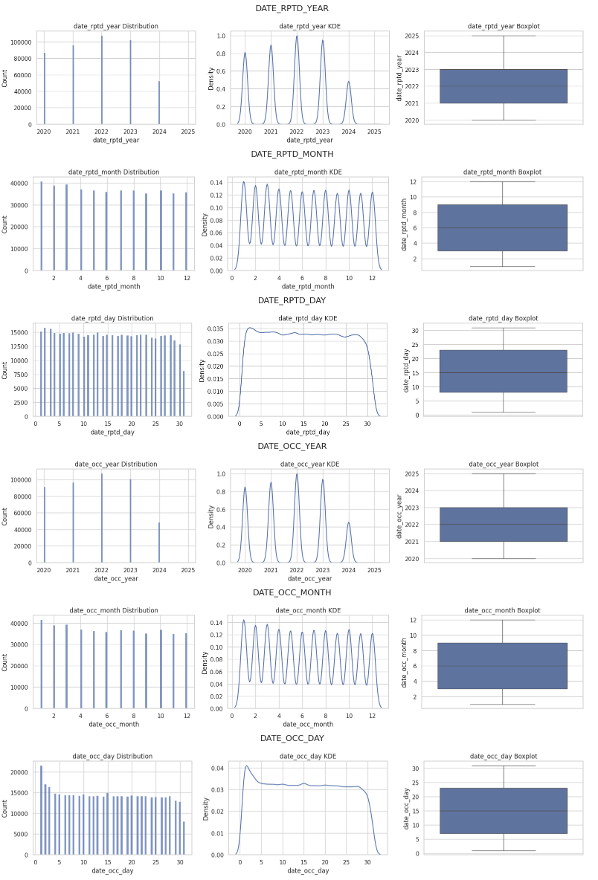
The initial exploration focused on the overall reporting behavior. The figure below shows the distributions of crime occurrence and report dates by year, month, and day. Crime counts show to peak around 2023, with a significant decline in 2024. When analyzing the monthly and daily patterns, they seem to be relatively stable, suggesting that crime reporting does not follow a strong seasonal trend at a broad level.

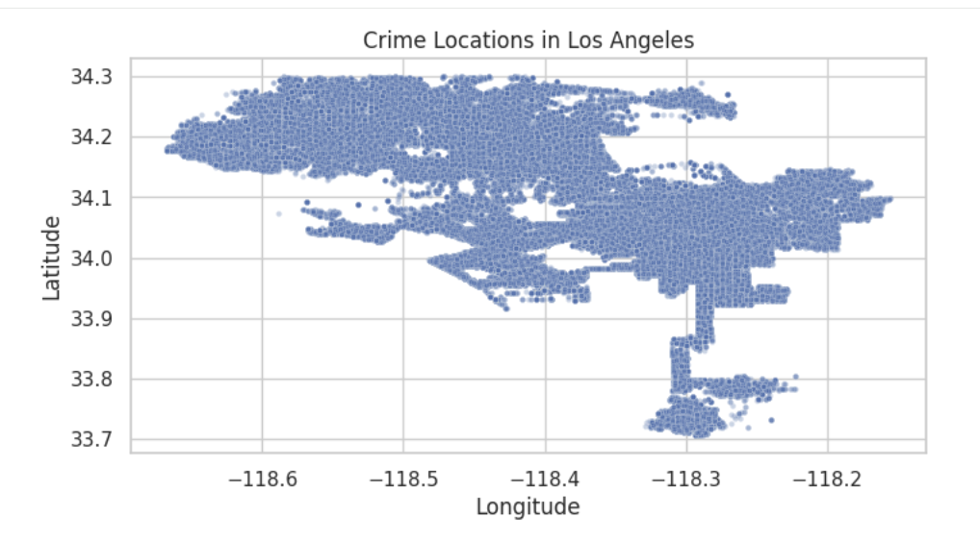
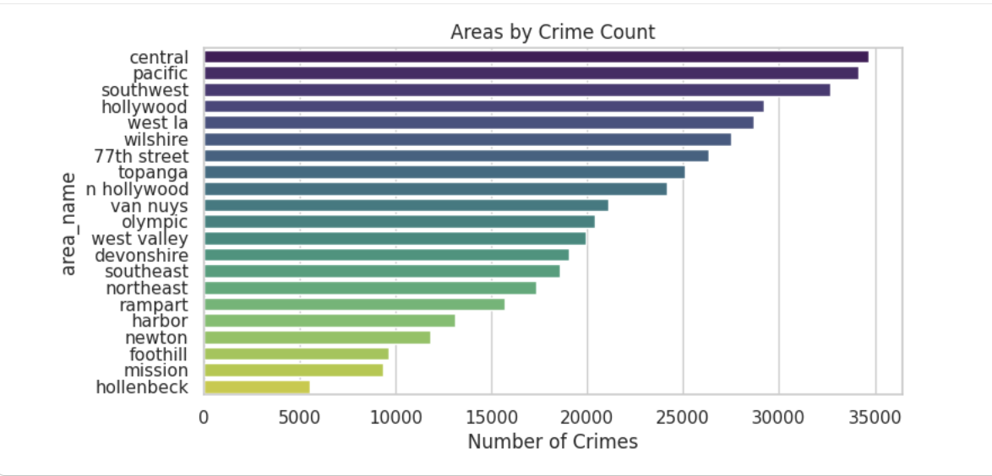
We then explored the geographic distribution of crimes. The figures contain plots of crime locations using latitude and longitude and show that crime incidents are highly concentrated within central Los Angeles rather than evenly distributed across the city. The second graph displays the pattern of total crime counts by LAPD area a little clearer. Areas like Central, Hollywood, and Pacific experience substantially higher crime volumes, whereas areas like Mission and Foothill report fewer incidents. Instead of indicating random fluctuation, these differences point to ongoing spatial vulnerability.

We then examined victim demographics to better understand who is most affected by crime. The histogram and boxplot displays the distribution of victim age and shows a unimodal pattern centered around young and middle aged adults. Crimes involving very young or elderly victims are less common but still present.
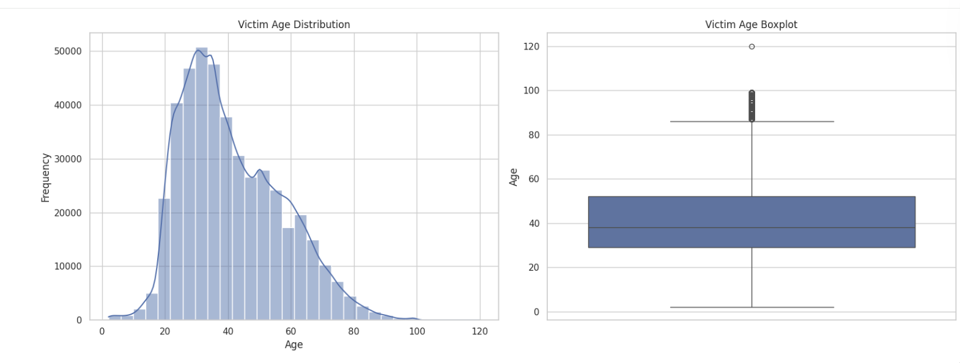
We then created a histogram that displays victim age but broken down by crime type. Clear differences emerge showing that violent crimes tend to involve younger victims, while non-violent crimes, typically fraud related offenses, disproportionately affect older adults.
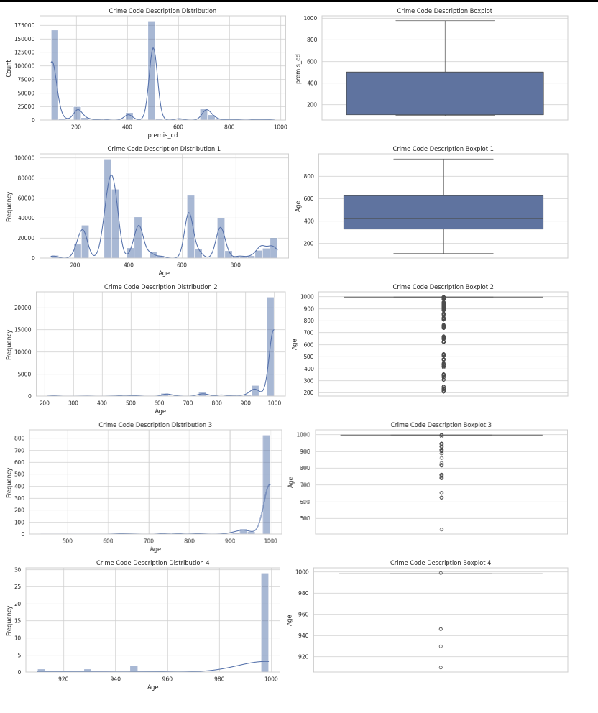
Temporal patterns were also explored. We examined the crime frequency by the hour of occurrence and discovered that incidents peak during evening and late night hours. The table also suggests that time of occurrence may influence how quickly a crime is reported, potentially due to accessibility or perceived urgency.
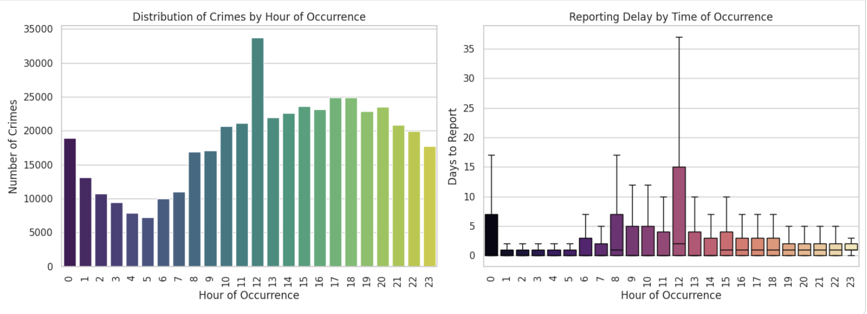
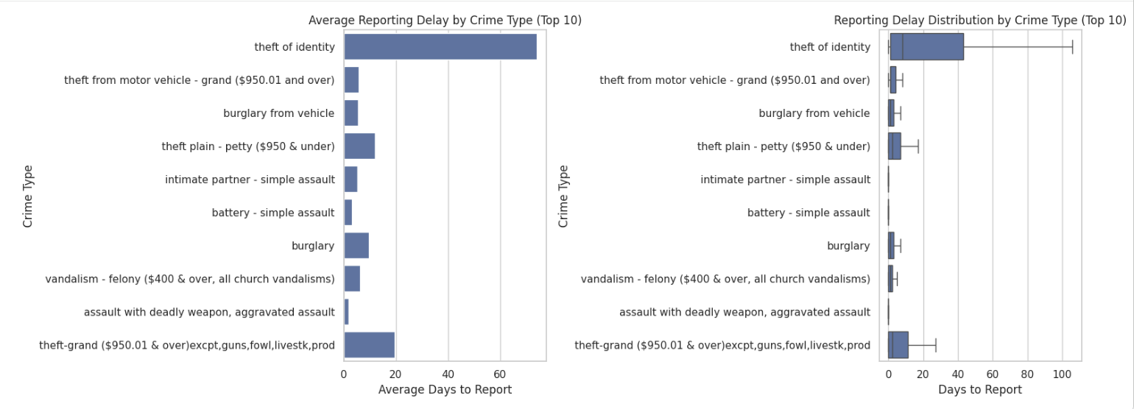
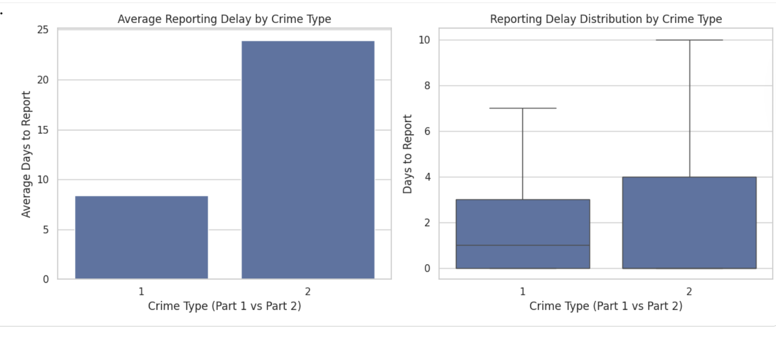
We then examined reporting delay more directly by creating a graph that shows the average reporting delays by LAPD area and reveals meaningful variation between districts. Some areas consistently experience longer reporting delays than others, which may reflect differences in access to reporting resources, community trust or socioeconomic factors. Additionally examined was the reporting delay between violent and non-violent crimes. We found that violent crimes are reported significantly faster and with less variability, while non-violent crimes exhibit longer and more dispersed delays. This pattern provides strong preliminary support for hypothesis 1.

Lastly, the relationship between crime concentration and reporting behavior was explored. The scatterplot displays the relationship between crime concentration and reporting behavior by comparing total crime volume with average reporting delay by LAPD area. While some high crime areas also show longer reporting delays, this relationship is not consistent across all areas. This suggested that crime intensity and reporting behavior are related but distinct processes that should be modeled separately.
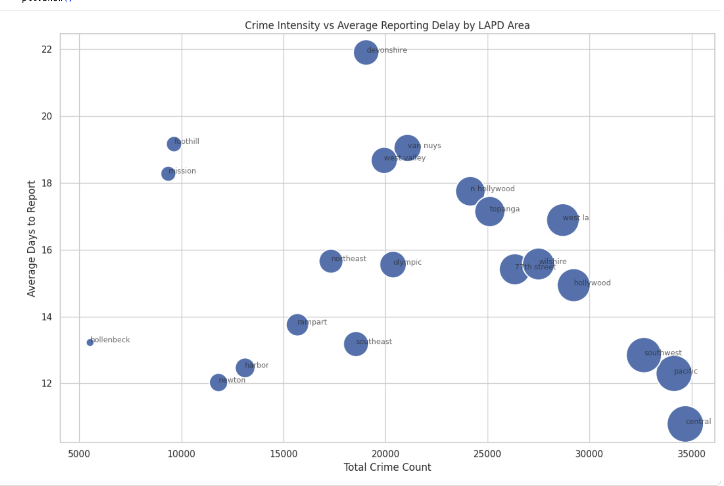
From this information, a conclusion can be drawn about relationships between crime type, time of occurrence, geographic location, victim demographics, and reporting behavior. These findings guided the decisions used later in the project and confirm that the dataset contains meaningful structure relevant to all 3 research questions.

Methods

Our attempts at determining the crime reporting delays relied heavily on the data provided by the LAPD and public government data sets. Several preprocessing steps were taken before modeling, including the cleaning of data that did not contain timestamps making it hard to determine reporting delay as well as removing victim ages that were recorded as 0 or implausible values. Reporting delay was calculated as the difference in days between the date a crime occurred and the date it was reported. Exploratory plots show that reporting delay is right skewed, with most incidents reported within a few days but a long tail extending beyond 60 days and because of this skewness, reporting delay was later converted into a classification variable rather than modeled purely as a continuous outcome.
Crime types were also grouped into violent (part 1) and non-violent (part 2) categories based on LAPD crime classifications. Temporal variables including house of occurrence, day of month, and month were extracted from the original date fields and spatial variables were constructed using LAPD area identifiers.
Research Question 1: Predicting Crime Reporting Delays in Los Angeles
Reporting delay was framed as a binary classification problem. Crimes reported within 48 hours were labeled as timely, while crimes reported after 3 days or more were labeled as delayed. Incidents reported between these thresholds were excluded to create clearer and separation between classes. Bar charts and boxplots comparing violent and non-violent crimes show that violent crimes have an average reporting delay of approximately 8 days, while non-violent crimes average over 23 days. The boxplots also show that nonviolent crimes exhibit longer upper tails, proving that delay behavior differs by crime severity.
The time of day plots show that times that occur over night, (between 12am - 5am), tend to have longer median reporting delays than daytime crimes, which supports the inclusion of hour of occurrence as a predictor. Day of month plots show relatively stable averages across most days, with the exception of day1, which exhibits a high mean due to outliers. And because the distributions by day of month are relatively flat, that variable was included but did not dominate model performance.
All results were assessed using a combination of visual diagnostics, numerical metrics, and statistical testing for each research question. Our modeling focused on predicting crime reporting delays in Los Angeles. We ran four models suited for binary classification, including decision tree, random forest, logistic regression, and XGBoost. Model performance was evaluated using accuracy, with the best performing model being XGBoost at 98% accuracy in both training and testing, achieving a 26% improvement over the baseline prediction of 72% accuracy.

Research Question 2: Crime Hotspot Intensity Across Los Angeles
To analyze crime concentration, incidents were aggregated by LAPD area and time period, producing crime counts per area. Exploratory bar charts show that crime is uneven across areas with Central, Pacific, Southwest, and Hollywood, exceeding over 30,000 incidents each, whereas Hollenbeck and Mission had less than 10,000 incidents each.
Scatterplots comparing total crime count and average reporting delay show no strong linear relationship, indicating that crime intensity and reporting behavior should be treated as related but distinct processes.
Crime counts were modeled using count based regression methods. Poisson regression was considered initially but exploratory variance checks suggested overdispersion. As a result, negative binomial regression was used better to account for excess variance in crime counts.
The temporal heat maps also show that crime intensity peaks during evening and late night houses, specifically between 6pm and 12 am, and that high crime areas remain consistently high over the years.

Research Question 3: Victim Age Patterns in Los Angeles Crime
Victim age was modeled both as continuous variable and as grouped categories such as children, young adults, middle aged, and seniors). Histograms show a unimodal age distribution centered around the late 30’s with a median victim age near 38-40 years. Box plots reveal a right tail extending into older ages with seniors appearing as less frequent but meaningful outliers.
Plots comparing victim age by crime type show that violent crimes skew younger while non violent crimes such as fraud and identity theft skew older. Time of day plots further show that late night crimes disproportionately involve younger victims, while daytime crimes more frequently affect middle aged and older individuals.

Methodology
Our project will use statistical and predictive modeling to analyze crime patterns in LA by using the public crime data specifically between 2020-2025. Our overall goal is to understand how crime reporting behavior, crime concentration, and victim age patterns vary across time, location, and crime characteristics.
Before completing an analysis, we will clean and prepare the data set by removing records with invalid/missing dates, handling missing demographic values and creating new variables as needed. The most important variable would be ‘crime reporting delay’ as it calculates the difference between the date and time a crime occurred and when it was actually reported to LAPD.
The research will be transformed into a classification problem. We will have the crimes labeled as either reported within 48 hours or reported with a significant delay (3+ days). Decision Tree, random forest, logistic regression, and XGBoost, will be used to determine which factors such as crime type, victim demographics, location, and time to help us predict delayed reporting.

Computation method and output
Our attempts at determining the crime reporting delays relied heavily on the data provided by the LAPD and public government data sets. Several preprocessing steps were taken before modeling, including the cleaning of data that did not contain timestamps making it hard to determine reporting delay as well as removing victim ages that were recorded as 0 or implausible values. Reporting delay was calculated as the difference in days between the date a crime occurred and the date it was reported. Exploratory plots show that reporting delay is right skewed, with most incidents reported within a few days but a long tail extending beyond 60 days and because of this skewness, reporting delay was later converted into a classification variable rather than modeled purely as a continuous outcome.
Crime types were also grouped into violent (part 1) and non-violent (part 2) categories based on LAPD crime classifications. Temporal variables including house of occurrence, day of month, and month were extracted from the original date fields and spatial variables were constructed using LAPD area identifiers.

Output Summary
Reporting delay was framed as a binary classification problem. Crimes reported within 48 hours were labeled as timely, while crimes reported after 3 days or more were labeled as delayed. Incidents reported between these thresholds were excluded to create clearer and separation between classes. Bar charts and boxplots comparing violent and non-violent crimes show that violent crimes have an average reporting delay of approximately 8 days, while non-violent crimes average over 23 days. The boxplots also show that nonviolent crimes exhibit longer upper tails, proving that delay behavior differs by crime severity.
The time of day plots show that times that occur over night, (between 12am - 5am), tend to have longer median reporting delays than daytime crimes, which supports the inclusion of hour of occurrence as a predictor. Day of month plots show relatively stable averages across most days, with the exception of day1, which exhibits a high mean due to outliers. And because the distributions by day of month are relatively flat, that variable was included but did not dominate model performance.
All results were assessed using a combination of visual diagnostics, numerical metrics, and statistical testing for each research question. Our modeling focused on predicting crime reporting delays in Los Angeles. We ran four models suited for binary classification, including decision tree, random forest, logistic regression, and XGBoost. Model performance was evaluated using accuracy, with the best performing model being XGBoost at 98% accuracy in both training and testing, achieving a 26% improvement over the baseline prediction of 72% accuracy.

Data Visualizations and Analysis
For the next phase of our analysis, we involved evaluating four classification models: XGboost, Logistic Regression, Random Forest, and Decision Tree.

XGboost:
For this model, validation accuracy increased sharply between depths 1 and 4 and stabilized around 0.9833 while validation accuracy was 0.9820, compared to a baseline of accuracy of 0.7227.
The gap between training and validation accuracy remained minimal across depths which suggests strong generalization and limited overfitting.
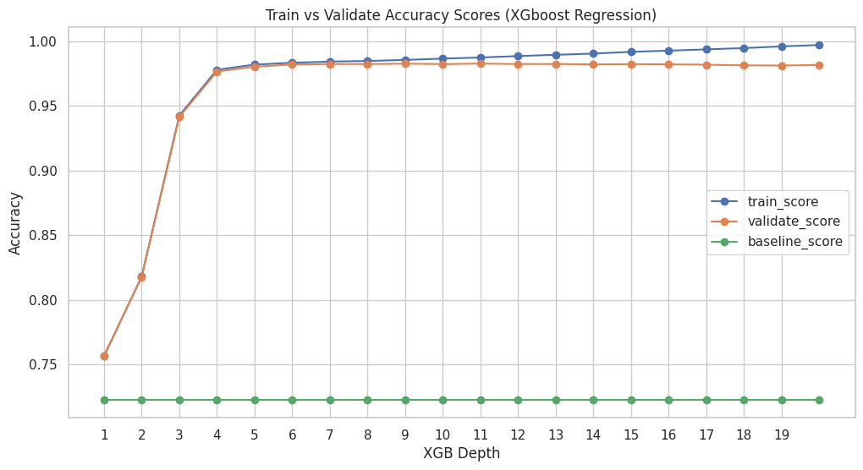

Logistic Regression:
For this model, training and validation accuracy remained stable at approximately 0.71 across all C values tested with an AUC of 0.516 throughout. The consistently low AUC indicates that despite reasonable accuracy, the model performs barely better than random chance at ranking predictions. This suggests that a linear decision boundary is insufficient to capture the nonlinear relationships present in the dataset.
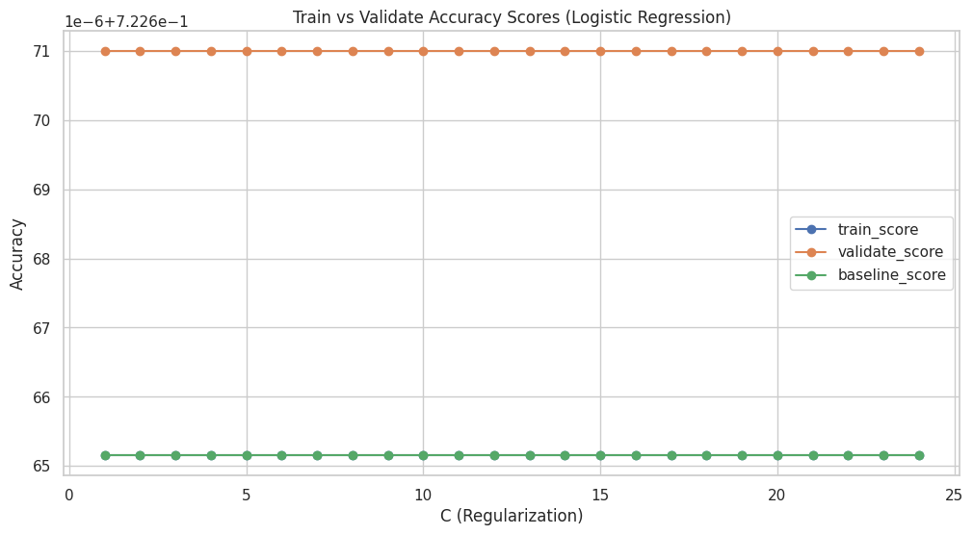
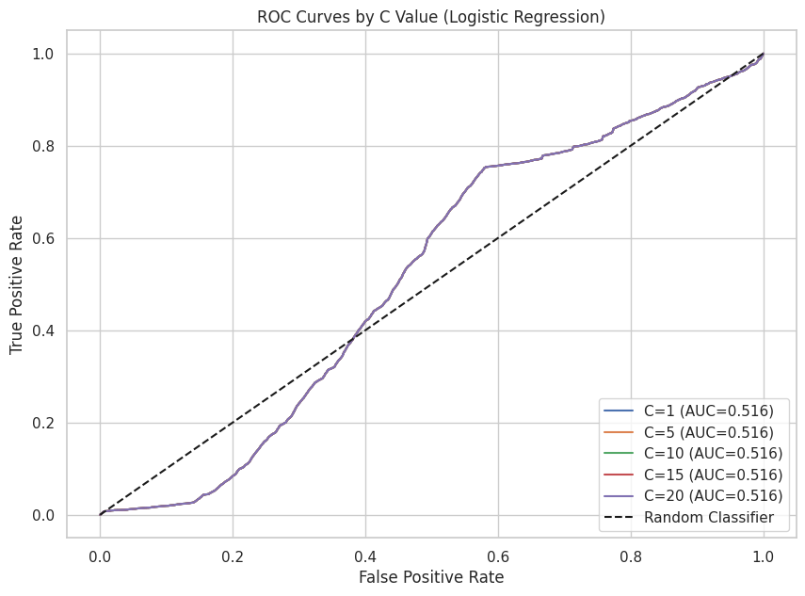
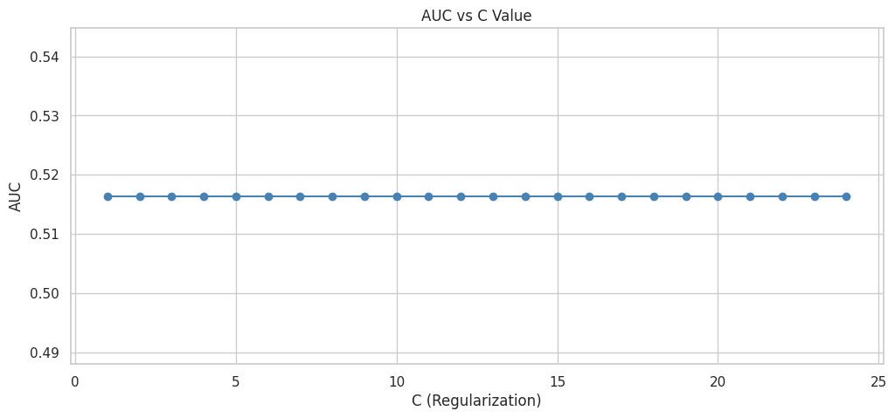

Random Forest:
This model demonstrated gradual improvement in validation accuracy as forest depth increased. Validation accuracy improved from about 0.72 to about 0.77 at higher depths. Training accuracy increased at a similar rate with a small gap between training and validation results.
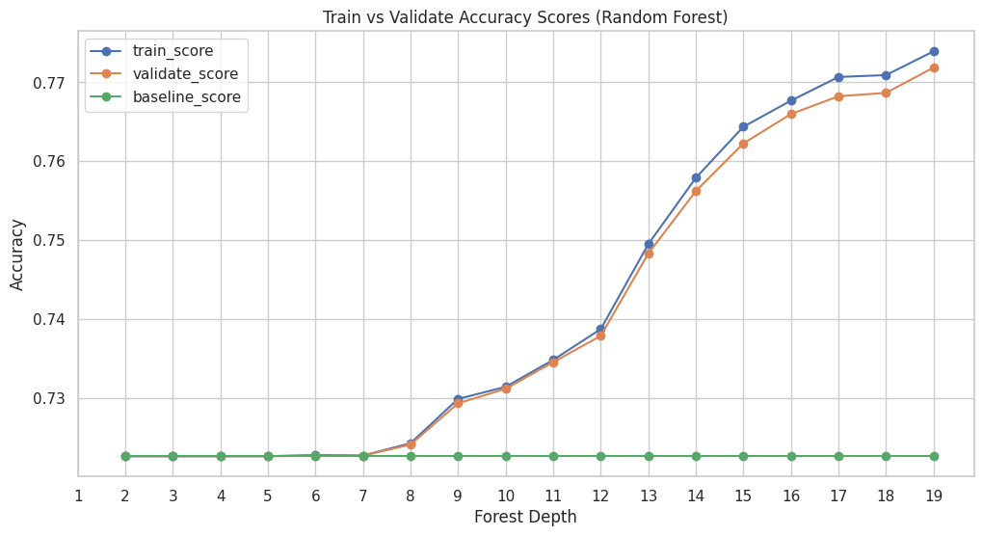

Decision Tree:
For this model, validation accuracy increased steadily as depth increased, reaching about 0.86-0.87 at higher depths. Though, training accuracy increased more rapidly, exceeding 0.95 at deeper levels. The widening gap between training and validation accuracy suggests increasing overfitting as tree depths grow. The model lacks stability, even though it captures a nonlinear structure effectively.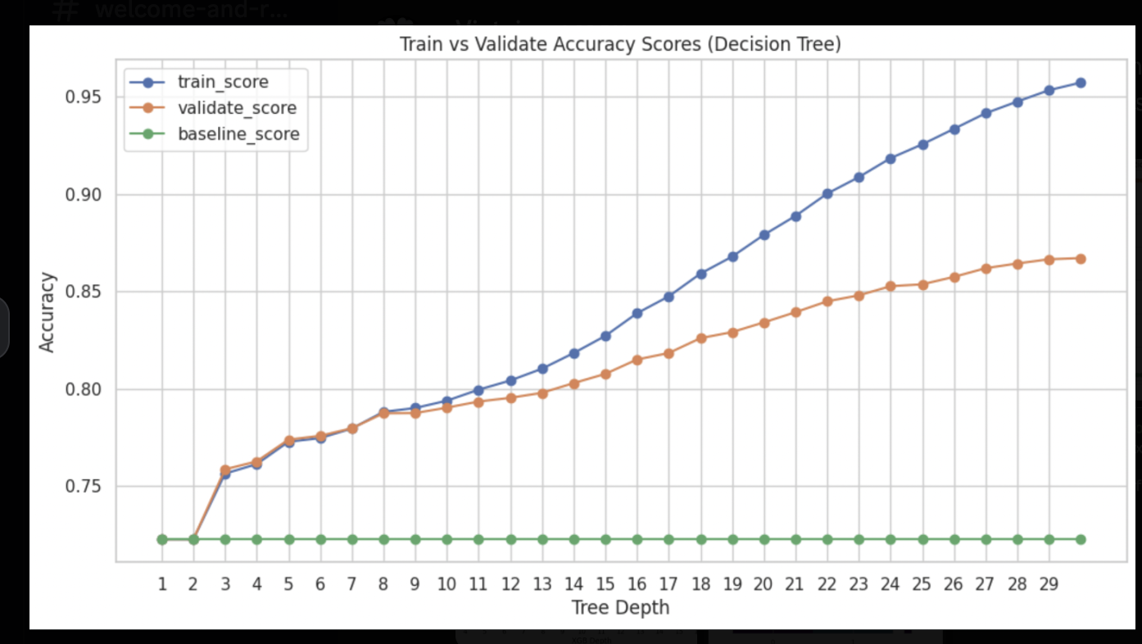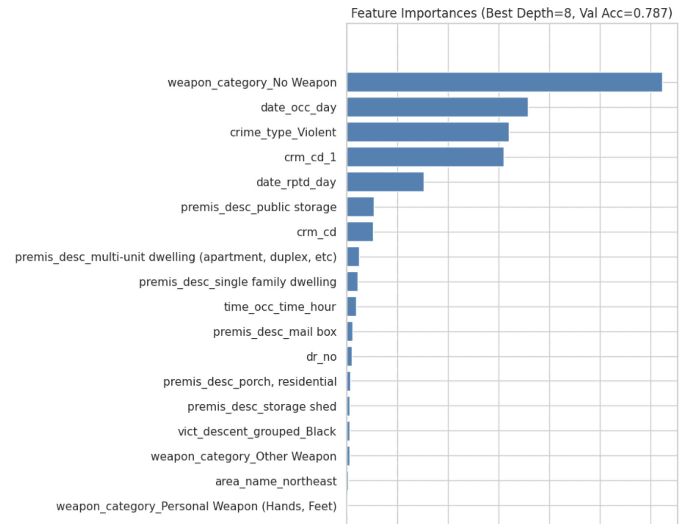
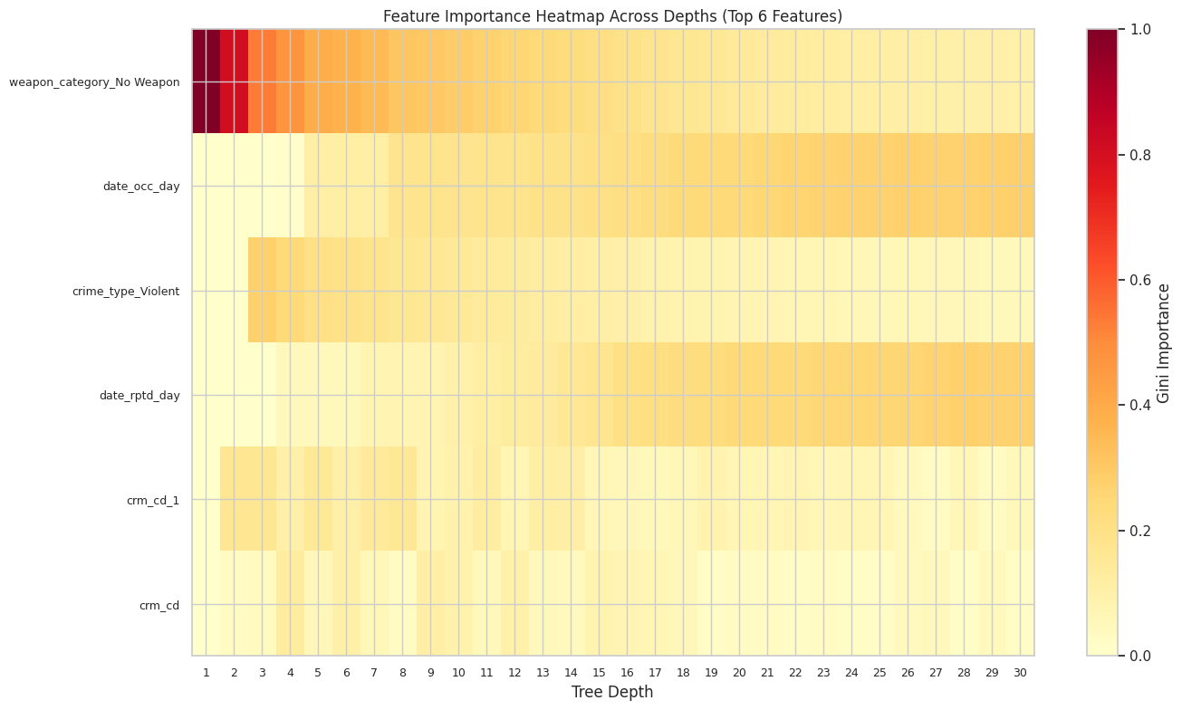

Post Analysis:
The XGBoost model performed very well, reaching an overall accuracy of 98% on the test set. This is a 35.5% improvement over the baseline accuracy of 72.27%. The classification report shows that XGBoost worked well for both classes. For low reporting delay (class 0), recall was perfect at 100%, and precision was high at 98%. For high reporting delay (class 1), precision was 99%, and recall was 94%. Both macro average and weighted average F1-scores were 98%, indicating the model effectively managed the class imbalance.
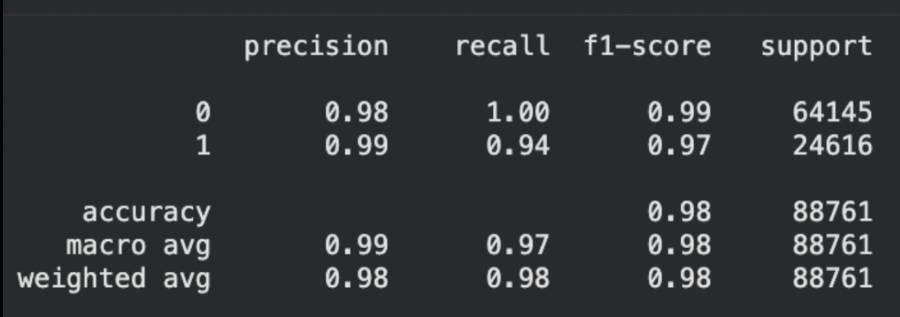
The confusion matrix supports these findings, with 64,025 true negatives and 23,141 true positives, and very few misclassifications. The model had only 120 false positives (0.19% error rate for low reporting delay) and 1,475 false negatives (6% error rate for high reporting delay). The low false-positive rate and strong true-positive results indicate that XGBoost learned to distinguish between the classes effectively. This makes it a strong choice for deployment, as it generalizes well and avoids overfitting.
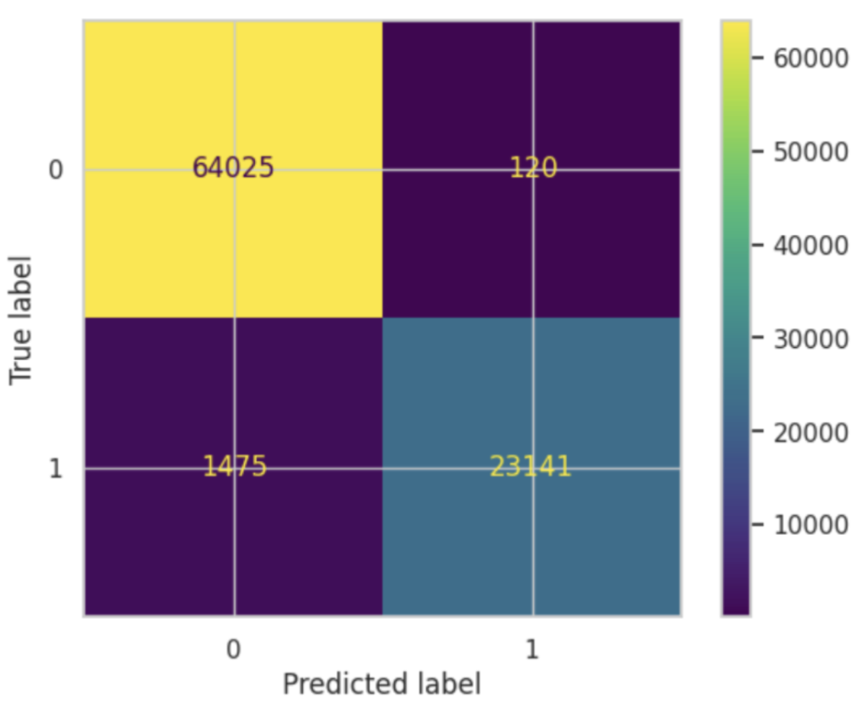

Challenges

Ethical Recommendations
Our review of LAPD crime data shows significant differences in how quickly crimes are reported, depending on the area, the people involved, and the type of crime. Even though the XGBoost model predicts these patterns with 98% accuracy, strong results do not mean it is always ethical to use. Before using these models to decide where to send patrols, we need to address three important concerns.
First, sending more police to areas flagged as hotspots can lead to over-policing in communities that already have frequent law enforcement contact. Central, Hollywood, and Pacific, for example, have both high crime rates and longer delays in reporting, but just adding more officers does not solve the reasons people wait to report crimes. Issues like language barriers, distrust of police, fear of retaliation, and not knowing how to report are likely causes. These communities might benefit more from tools in multiple languages, community liaison programs, and working with local organizations that residents trust.
Second, losing half the data because of missing information makes us question if our models truly represent all parts of Los Angeles. Missing data is not random; it often stems from problems in data collection, which likely affect marginalized neighborhoods the most. Before using the model, we need to ensure it works well across every LAPD area and group, not just where the data are complete. People should also know how their communities are labeled as hotspots and what that means for them.
Third, we must be careful not to let patterns in the data lead to stereotypes or make us pay less attention to certain cases. Our results show that violent crimes happen more to younger people, fraud affects older adults, and reporting times vary by victim sex. Still, these trends do not tell us about each person’s experience. Just because weapon-related crimes are reported faster does not mean we should doubt victims who take longer to report, since trauma affects everyone differently (Lanthier et al., 2018). Prevention programs should be shaped with community input to avoid messages that might stigmatize anyone.
In the end, crime is often a sign of bigger social issues like poverty, inequality, and past trauma (Patterson, 1991). Predictive models can help guide decisions, but using them responsibly means also investing in social support and solutions.

References
- Los Angeles Police Department. LAPD organization. https://www.lapdonline.org/lapd-organization/
- Los Angeles Police Department. History of the LAPD. https://www.lapdonline.org/history-of-the-lapd/
- Los Angeles Police Department. Community policing unit. https://www.lapdonline.org/community-policing-unit/
- North East Neighborhood Council. (2024, November). LAPD budget approved: $2.14 billion spending plan for 2025–26. https://nenc-la.org/2024/11/lapd-budget-approved-2-14-billion-spending-plan-for-2025-26/
- Lanthier, S., Du Mont, J., & Mason, R. (2018). Responding to delayed disclosure of sexual assault in health settings: A systematic review. Trauma, Violence, & Abuse, 19(2), 251-265. https://doi.org/10.1177/1524838016659484
- Patterson, E. B. (1991). Poverty, income inequality, and community crime rates. Criminology, 29(4), 755-776. https://doi.org/10.1111/j.1745-9125.1991.tb01087.x

Appendix

Code
Github LInk:

